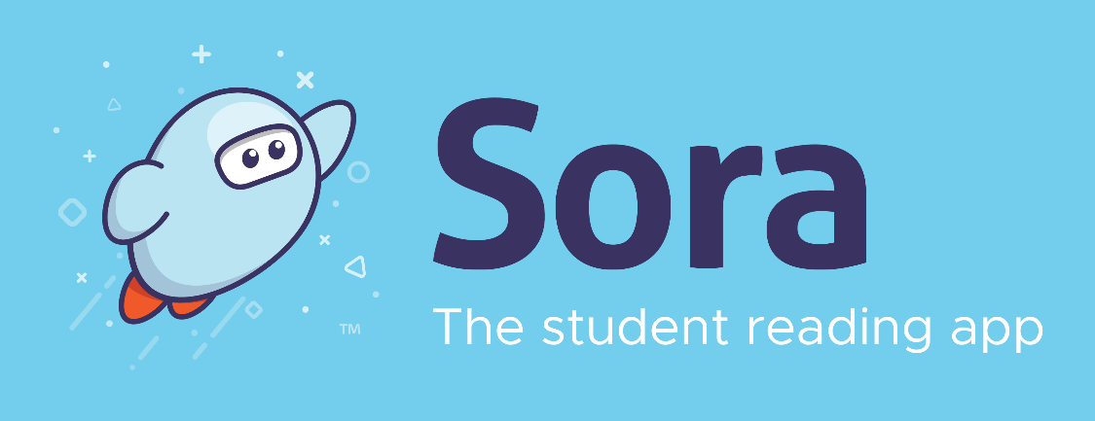
Instructions:

- Have students/staff download the SORA app (free) onto any device that has apps. You should also place a link on your school library website: soraapp.com for computer access.
- Find and click on:
‘British Columbia Interior/North K-12 Shared Digital Collection’
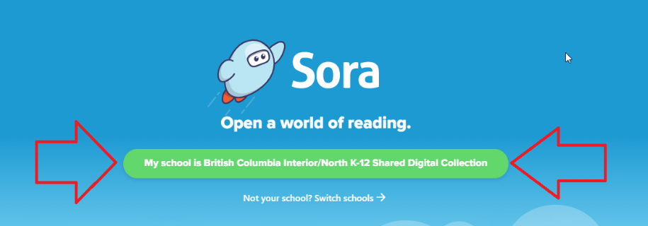
(If you can’t find this right away, click on ‘My School isn’t listed’ and then type in ‘British Columbia Interior’ and then under ‘Select My School’, find ‘School District 83’)
- Scroll down to find: ‘School District 83 North Okanagan-Shuswap’
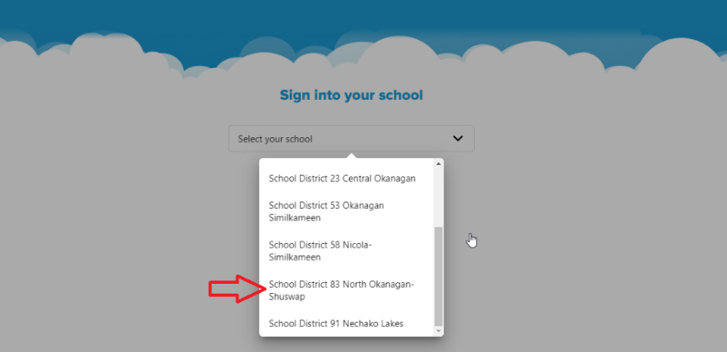
- Log in using your school username and password.

- Now you are in! Please see these informative videos from Overdrive (SORA): https://resources.overdrive.com/k-12-schools/how-to-videos/sora/

- Explore and enjoy before showing your students and staff during their library time soon!
Please note: Students in elementary only see elementary-level books. Middle students have access to elementary and middle level books. High School has access to all the books, including high school level books.

Additional Helpful Notes:
  - Under the Hamburger menu (top right) in SORA, students with a public library card and PIN can add the Okanagan Regional Library to have access to many more ebooks (still limited to age level which is great!)

  - Elementary: place the SORA app on your school’s ipads for classes to use to read in classrooms. Can be a nice buddy reading activity too.

  - Middle/High School: can read off their phones or any device

  - Read-alongs – are great for Elementary and even LRT use!

  - Audiobooks – Students can listen to a book or listen while following along using the print book - great for LRT at higher levels.

