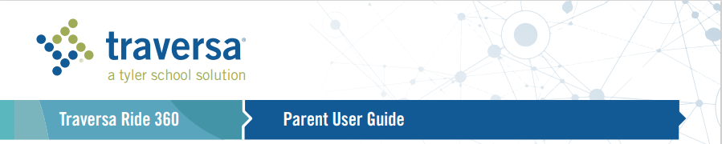

How to access the Traversa Ride 360™ website

1. Using the Chrome Internet browser, go to the URL provided by School District No. 83.
https://bcnokanaganssd83.traversaride360.com/

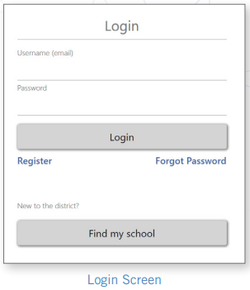
2. If you do not already have a registered email, click ‘Register’.

3. To register, enter your email address, password, and name.

4. After registering, you will receive a confirmation email. Click on the link in your
email to confirm your registration through the Ride 360 website.

5. Log in, then find a student by going to My Students and clicking the
‘Find Student’ button.

6. Enter the unique information required by your district to find your student.
Student ID and Birthdate YYYY-MM-DD
Repeat this step to add additional students. If you need assistance, please contact
your school district transportation department at 250-832-9415.

7. Once you have linked to a student, click on that student’s profile to see all
relevant transportation information.

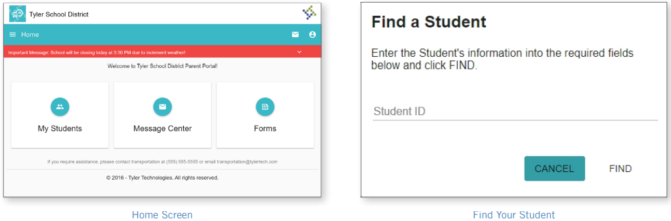

8. To share a student link with another person, select a student and click the student options button in the
lower-right corner.

9. Choose which students to share, then enter the email of the person you would like to share with. That person will receive a confirmation email that will automatically link them to the shared student(s). Recipients must register with Ride 360 (see first 4 steps), if they have not already done so, to access the student information.

…continued on back

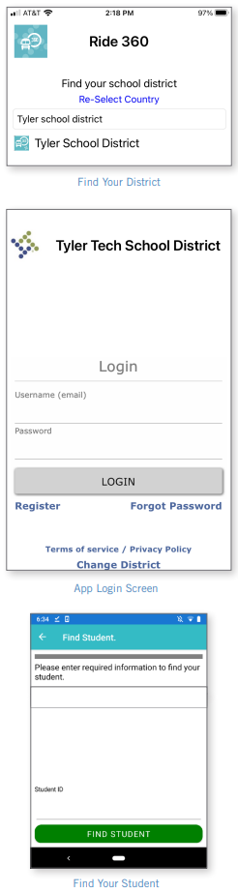
How to access the Traversa Ride 360 mobile application

1. Download “Traversa Ride 360” from the Google Play Store or the Apple
App Store.

2. After the app installation is complete, open Traversa Ride 360.

3. When prompted to find your school district, first select “Re-Select Country”
and ensure it lists Canada, then search for the name of the school district your
child attends. If you need assistance, please contact your school district.

4. Once you have selected your district, you will proceed to the login page.
If you do not already have a registered email, click ‘Register’.

5. To register, enter your email address, password, and name.

6. After registering, you will receive a confirmation email. Click on the link
in your email to confirm your registration through the Ride 360 website.

7. Log in, then find a student by going to My Students and choosing the +
button. This will present the Find a Student screen.

8. Enter the unique information required by your district to find your
student. Student ID & Birthdate YYYY-MM-DD Repeat this step to add
additional students. If you need assistance, please contact your school district.

9. Once you have linked to a student, click on that student’s profile to see
all relevant transportation information.

10. Press the “share” button to share a student link with someone else.
Enter the email of the person you would like to share with. That person
will receive a confirmation email that will automatically link them to the
shared student(s). Recipients must register with Ride 360, if they have
not already done so (follow first 6 steps), to access the student information.

11. Press the “location” button to access the busing information for your
Child. This will show you what the morning pick up information and afternoon
off information looks like for your child and whether or not the bus has been
delayed.

12. The menu at the top left of your phone screen allows you to change your
Settings, send the transportation department messages and contact information.

13. Regularly check for updates to ensure that your device is running the
latest version of the app.

14. Remain logged into the app to receive district notifications, even when
the app is not actively running.


For more information or any ongoing support such as username and password information, bus stop location questions, or other needs please contact School District No. 83’s transportation department.
Phone 250-832-9415 or Email operations@sd83.bc.ca

